**Scavenger Hunt**

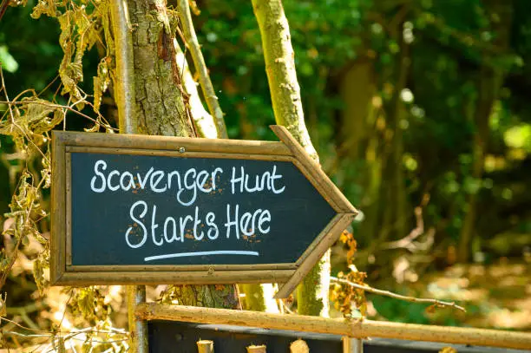

**Description**: Players or teams search for items from a list, often racing against time to find them all.

**How to Play**: Create a list of items for players to find. Players or teams race to find all the items within a set time.

**Location**: Backyard, park, neighborhood.

**Things Needed**: Scavenger hunt list, bags for collecting items.

**Players**: 2 or more.